**Employee Management Service**

🔹**Project Objective:**

i)Create an integration application for automating employee management service using TIBCO BusinessWorks 5.x

ii)To read the .csv file and based on the input of employee details, manage HR processes

iii)Implement error handling mechanism

🔹**TIBCO products and tools used:**

TIBCO BusinessWorks 5.x, TIBCO Designer, TIBCO Administrator, MariaDB

🔹**Features:**

Automated employee management: Based on the input CSV file, the application automates key HR processes:

- Hire Employees: Efficiently onboard new employees.

- Promote Employees: Manage employee promotions based on predefined criteria.

- Employee separation: Handle employee separation as per the instructions.

- Log Details: Log all actions into the database for record-keeping and auditing.

🔹**Activities Used:**

- Parse palette: Parse Data

- General Activity Palette: Write to log, Mapper, Timer, Catch, Generate error, Assign

- JDBC Palette: JDBC query, JDBC update

- XML Activities: Render XML

- File Palette: Read file, Write file

-Java: Java code

**🔹Efficient Deployment and Management:**

Utilized TIBCO Administrator for effective deployment, management, and monitoring of the application, ensuring smooth and efficient operations.

**🔹 Enhanced Monitoring & Troubleshooting**:

Handled errors and exceptions using Catch and Generate error activities, and dumped logs into the database. Specific error scenarios include:

- If an employee doesn't exist.

- If the file doesn't exist.

- If the file is empty.

The application throws exceptions and logs error details into the database for quick resolution.

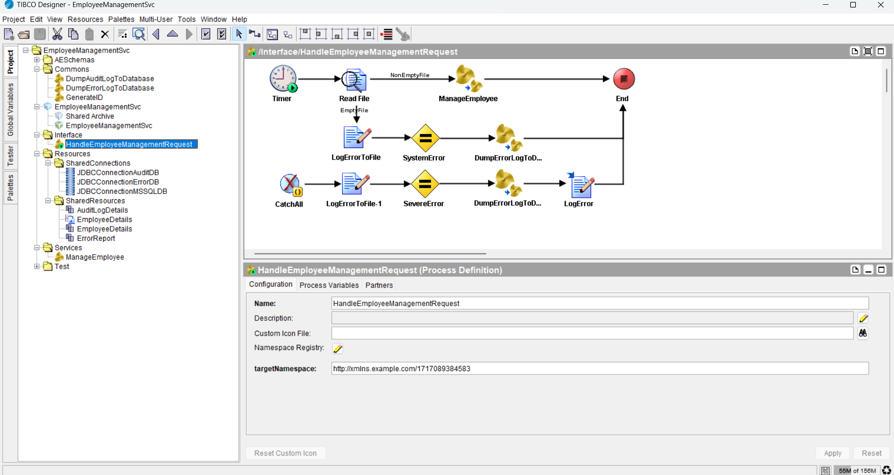

I have published the BW code on GitHub repository:

<https://github.com/pawas17/TIBCO-BW-5.x-Case-Studies/tree/main/EmployeeManagementSvc>

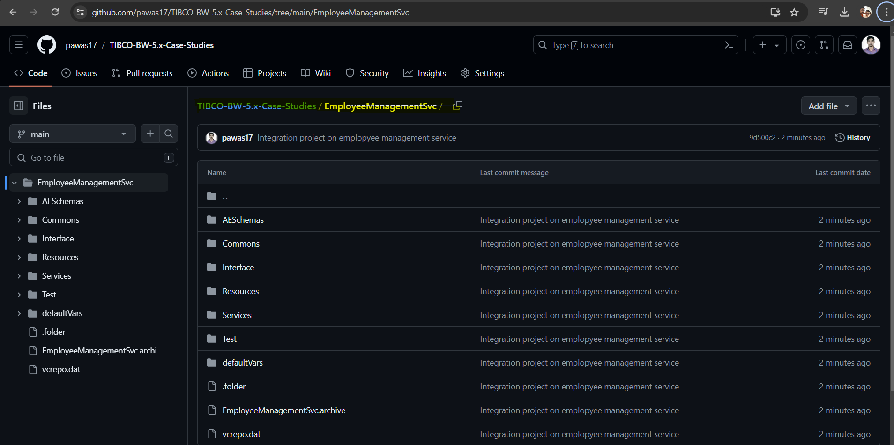

**Project implementation:**

**Scenario 1:** Hire Employees

**A)Success scenario: Employee doesn’t exist**

Read an input file:

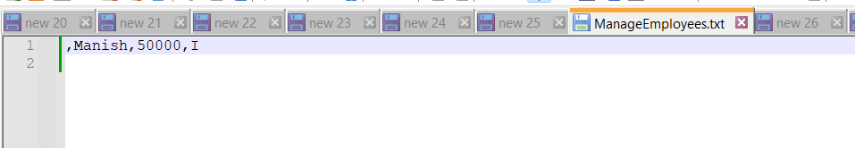

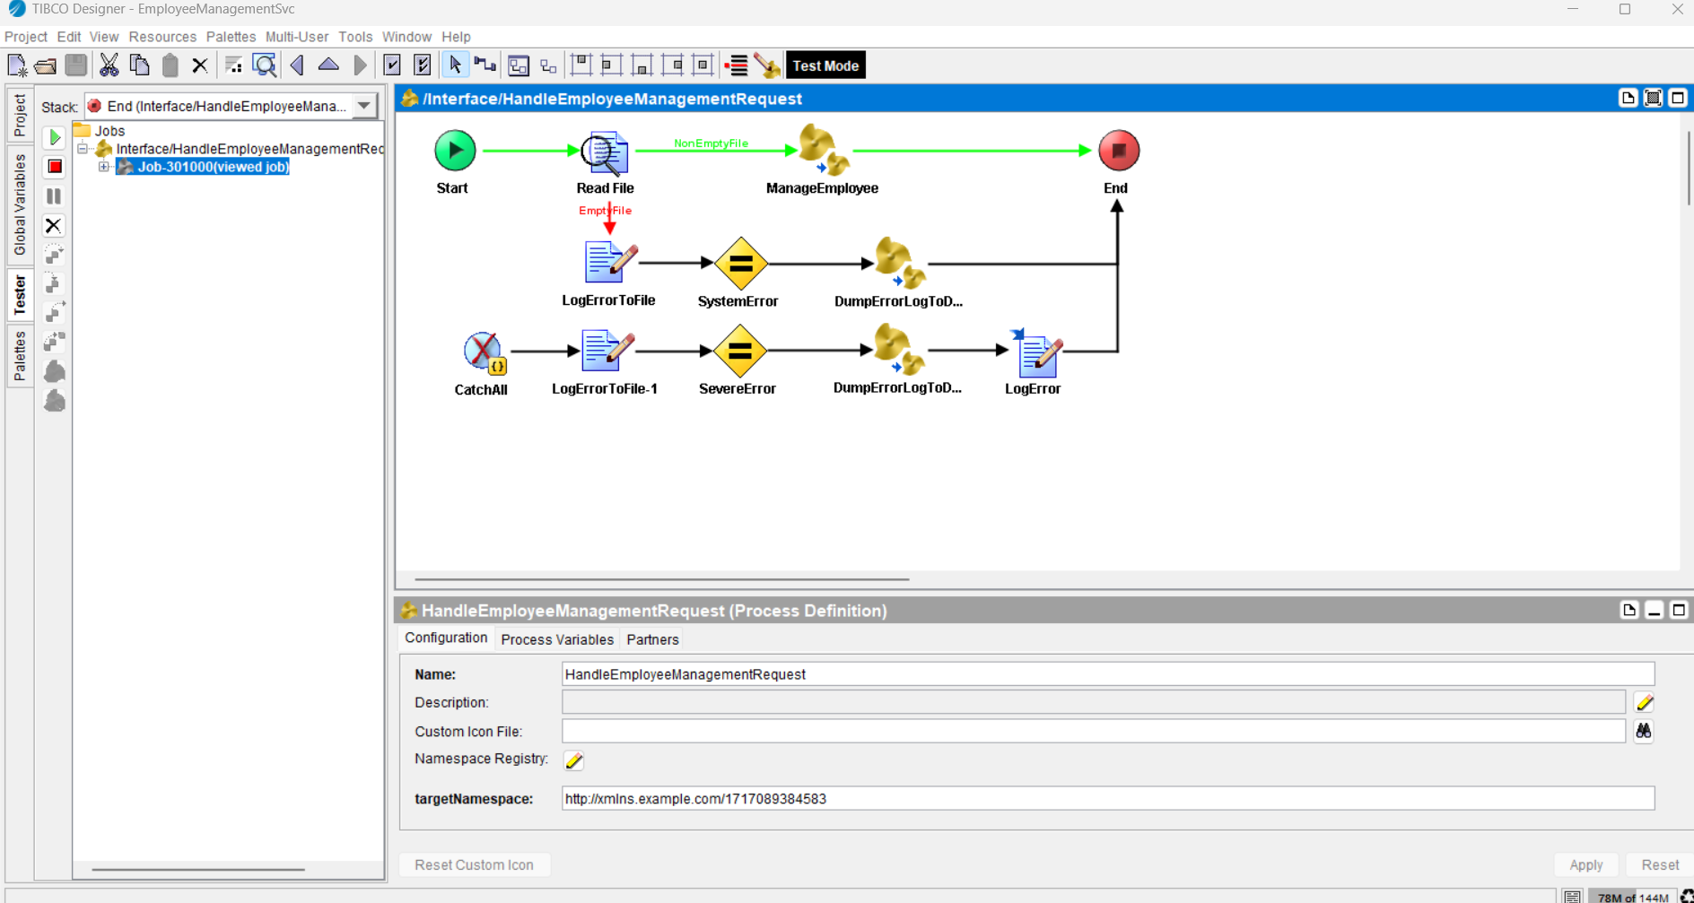

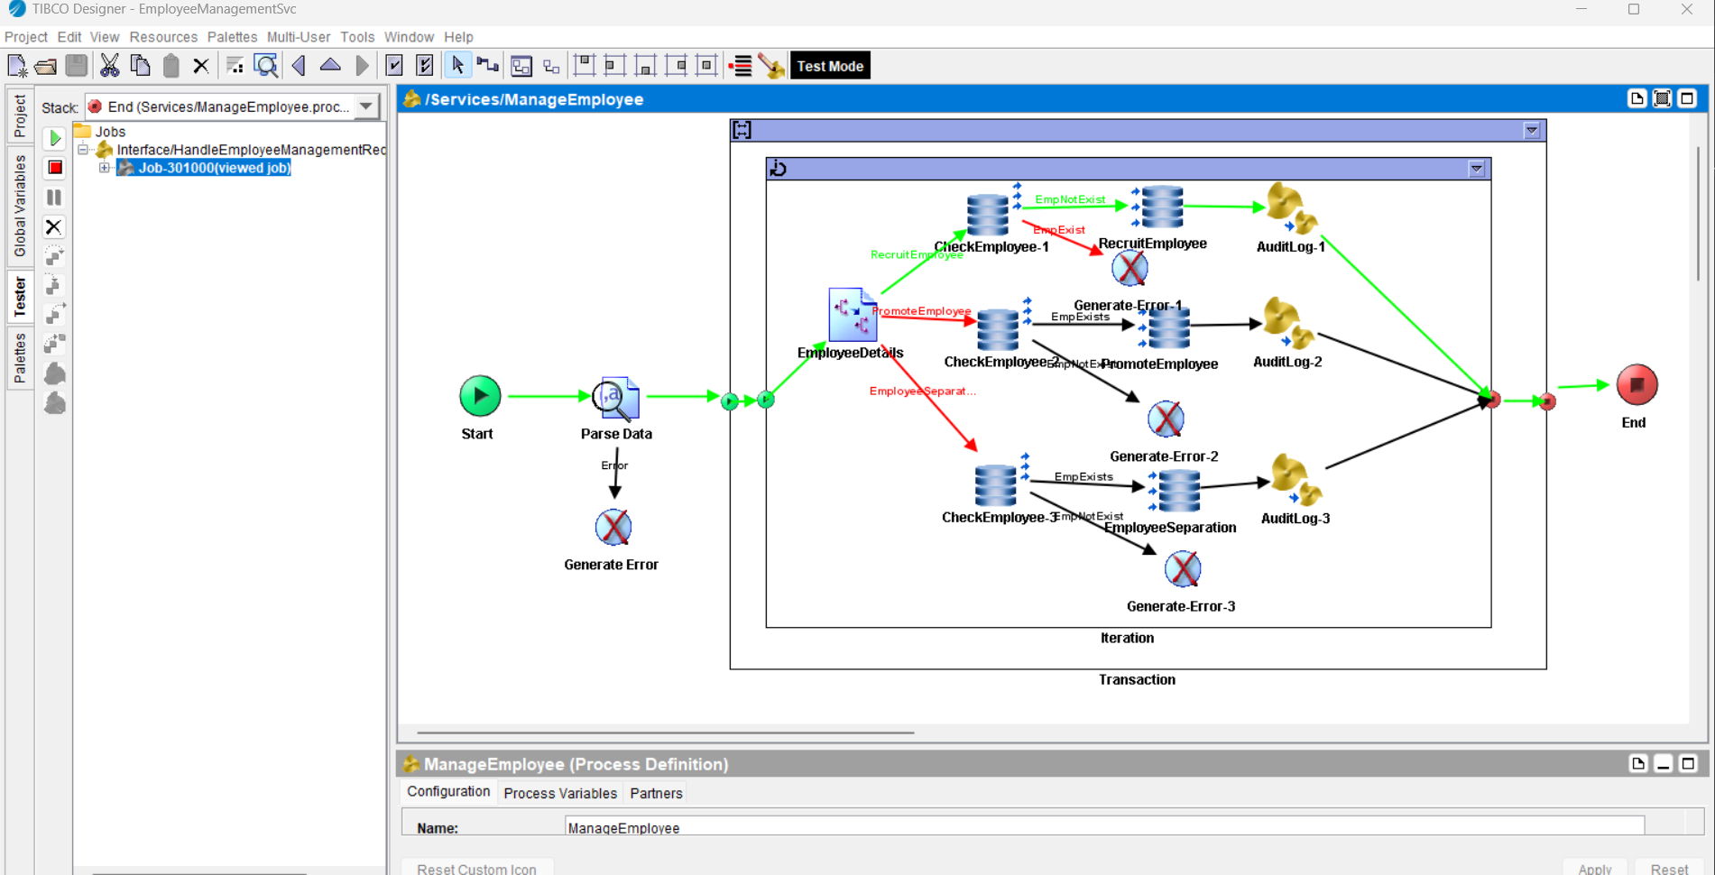

Employee details are added successfully into the database table: Employee

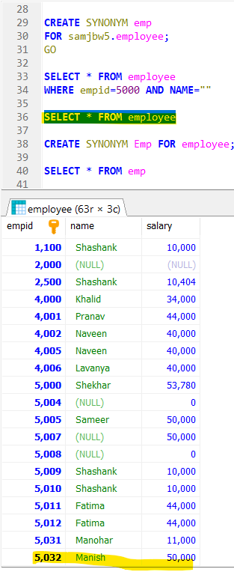

Input details are dumped into the database for audit purpose.

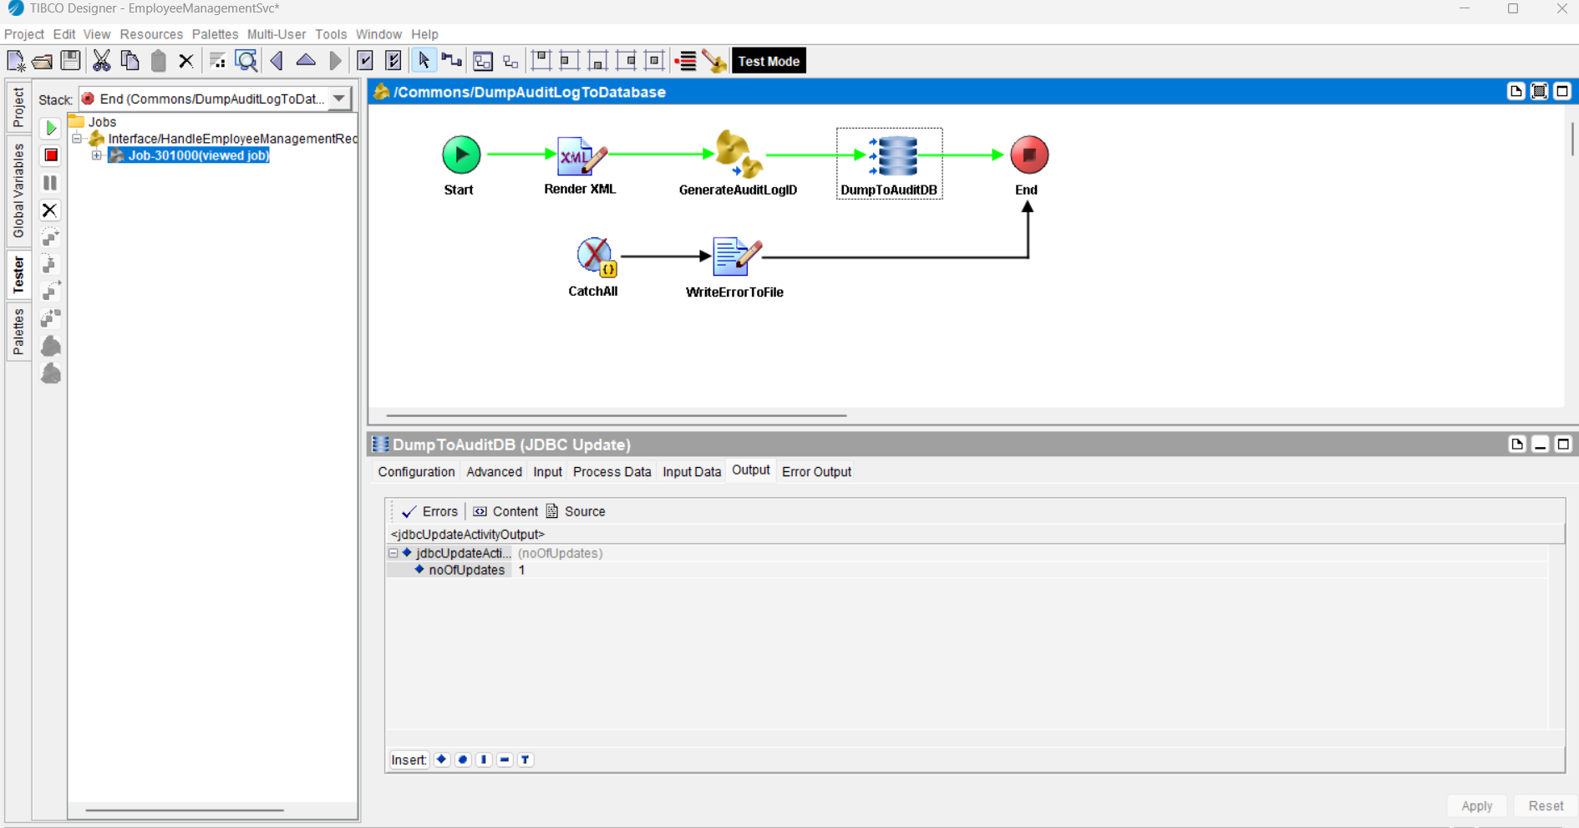

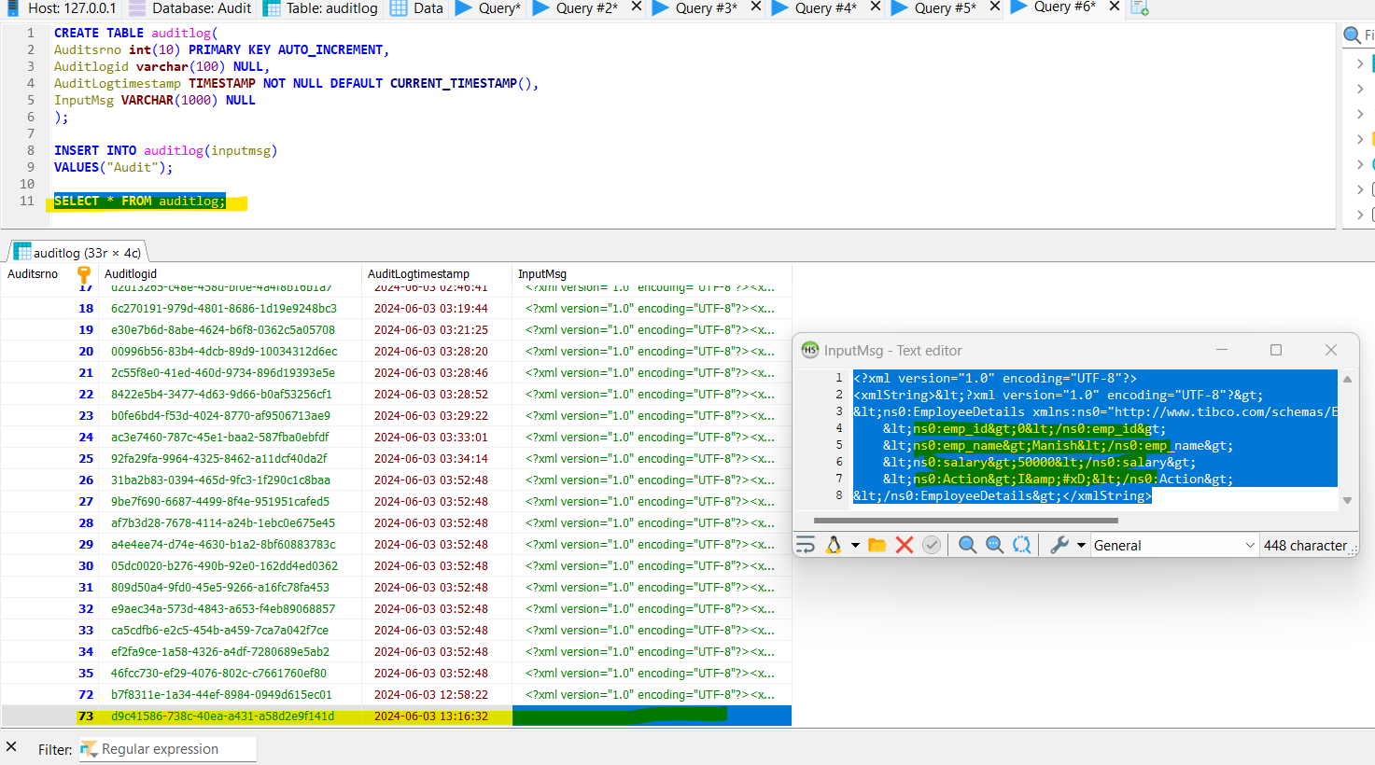

**B)Error scenario: Employee already exists**

Read an input file with an employee id already exists:

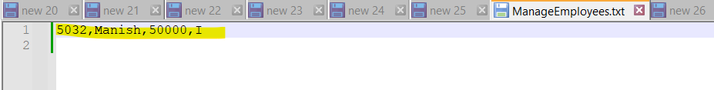

It identified that that exployee already exist, hence it catched the exception and error logs are dumped into the database.

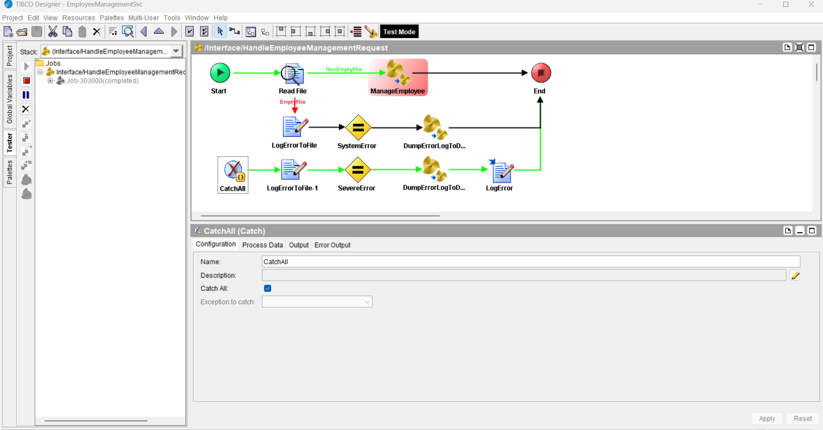

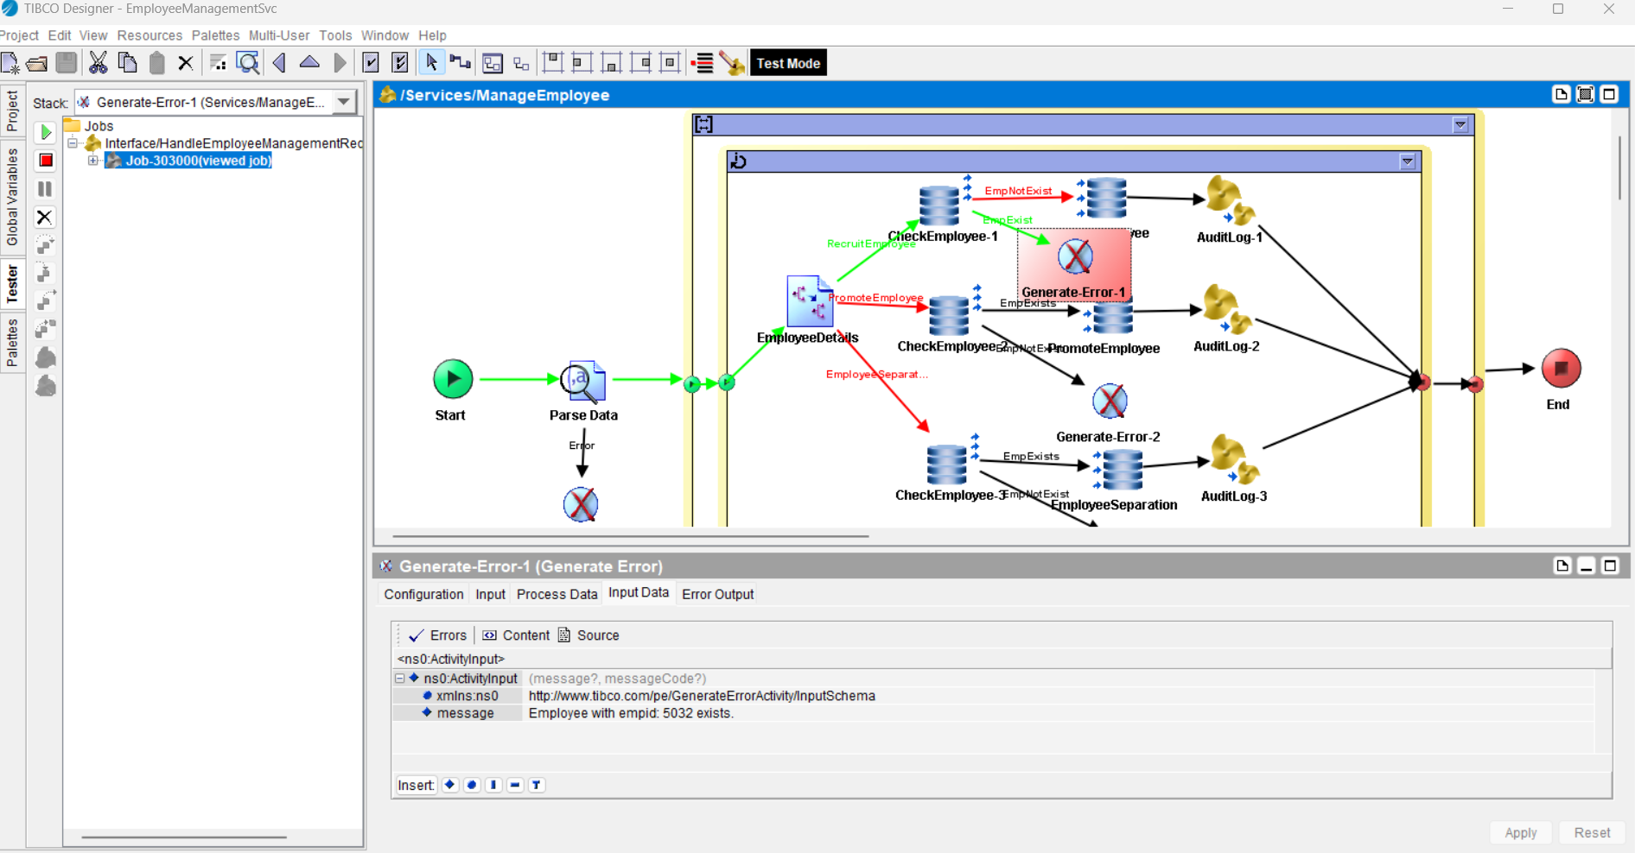

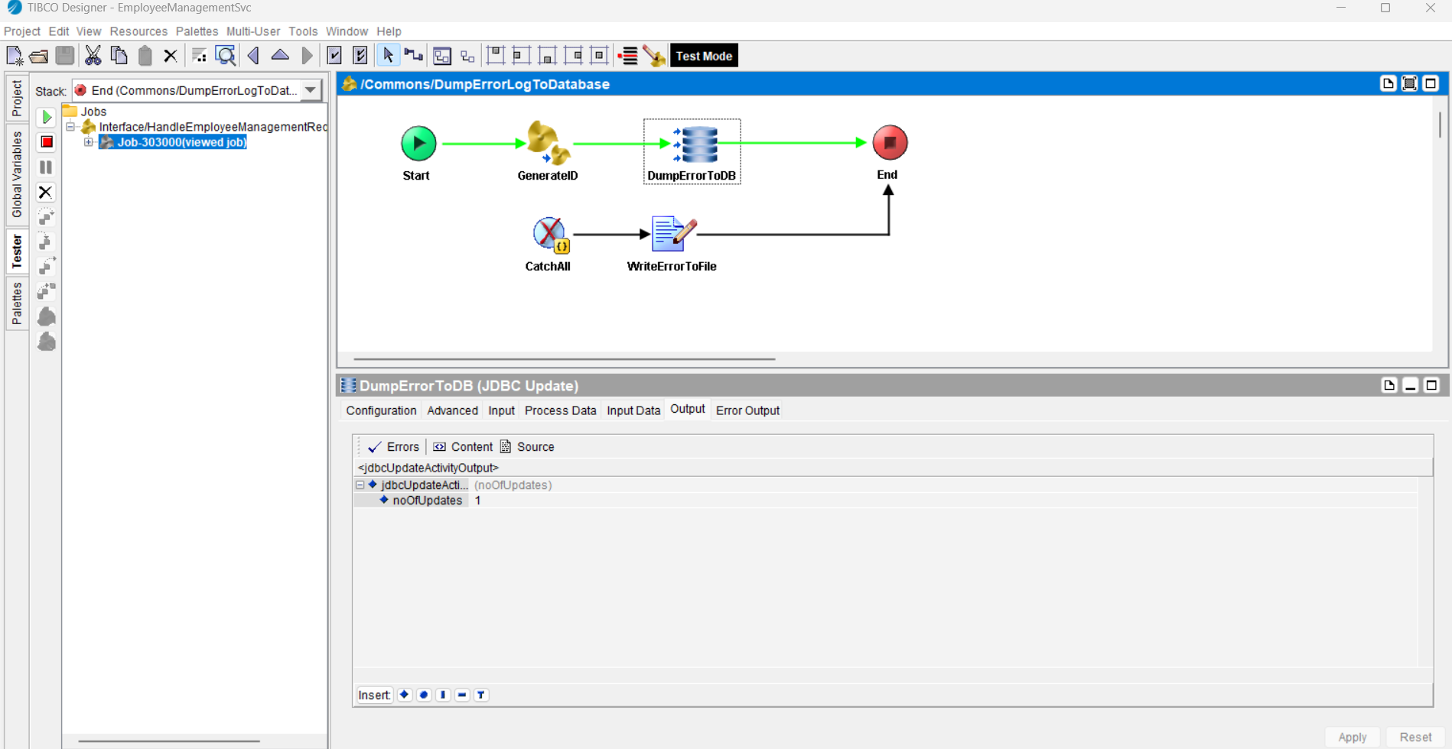

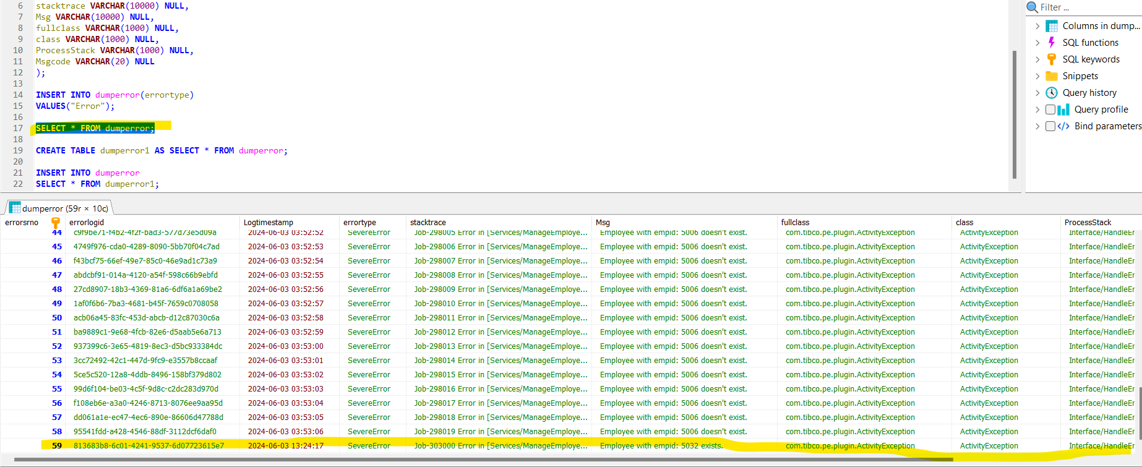

**Scenario 2:** Promote Employees

**A)Success scenario: Employee exist**

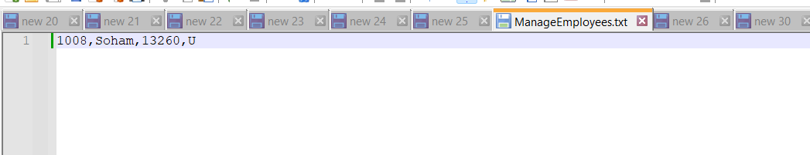

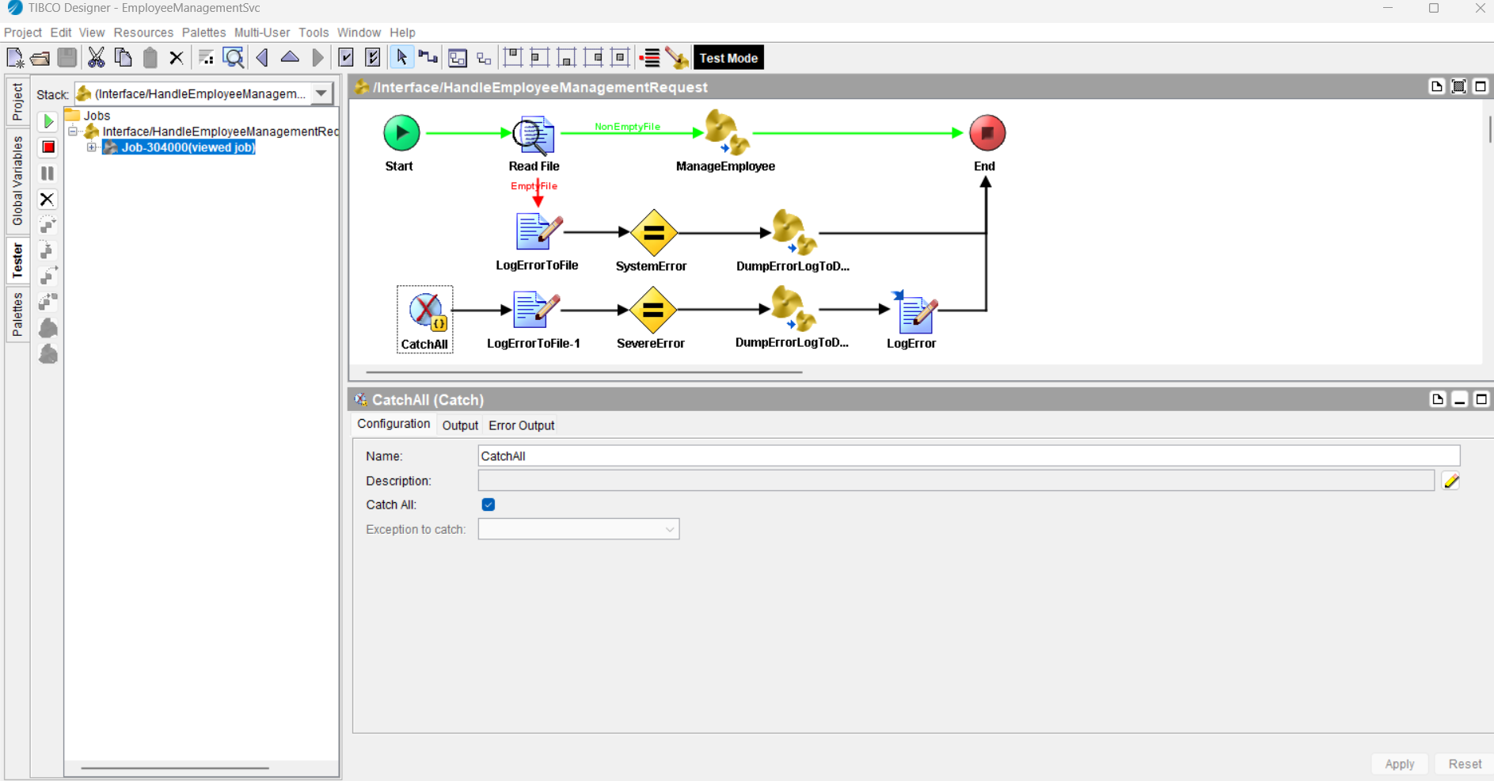

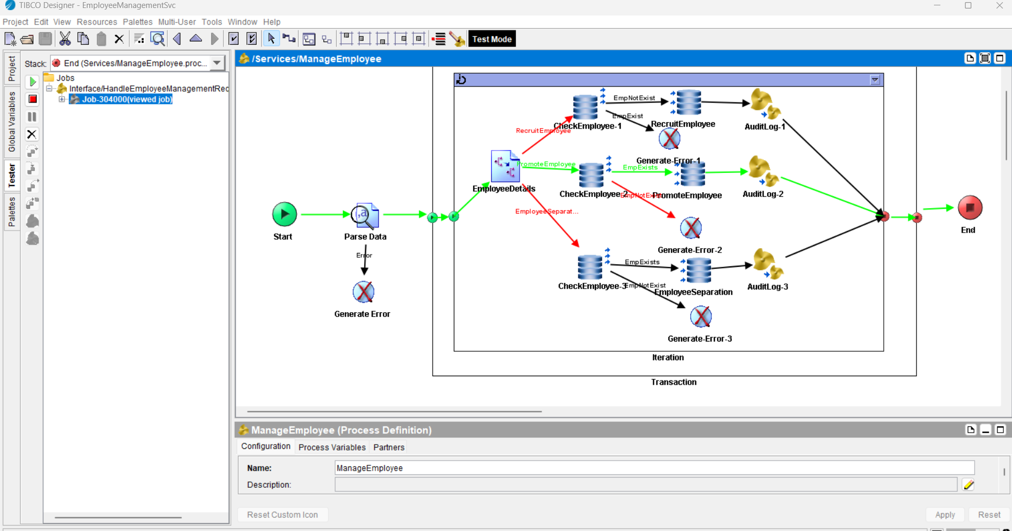

Employee salary has been incremented as per the logic.

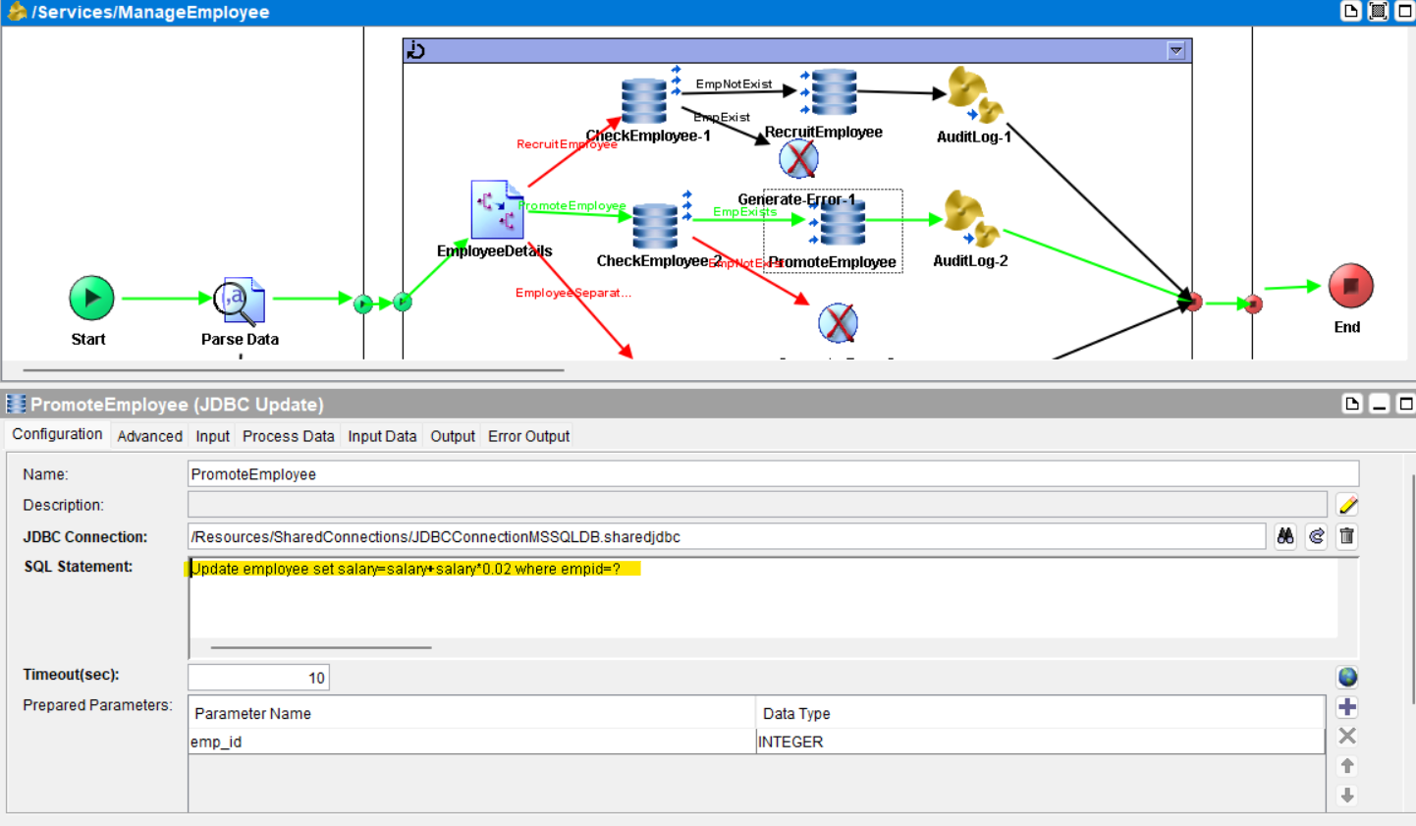

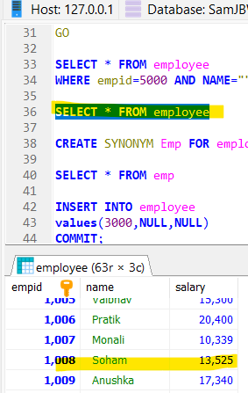

Input details are logged into the database for audit purpose.

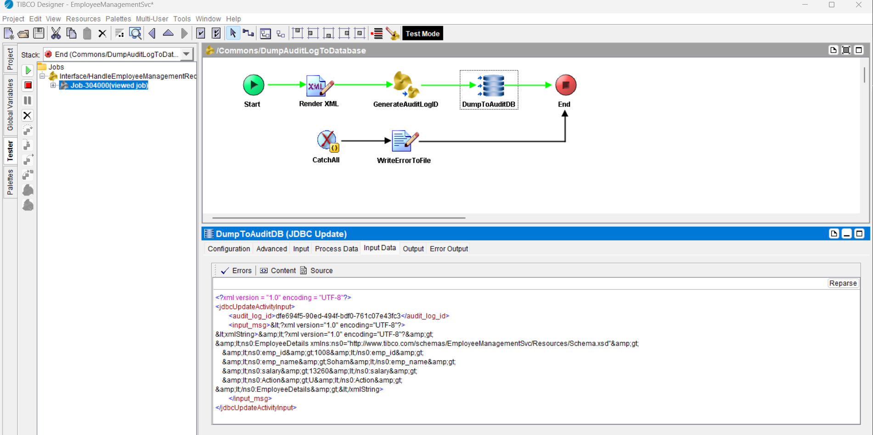

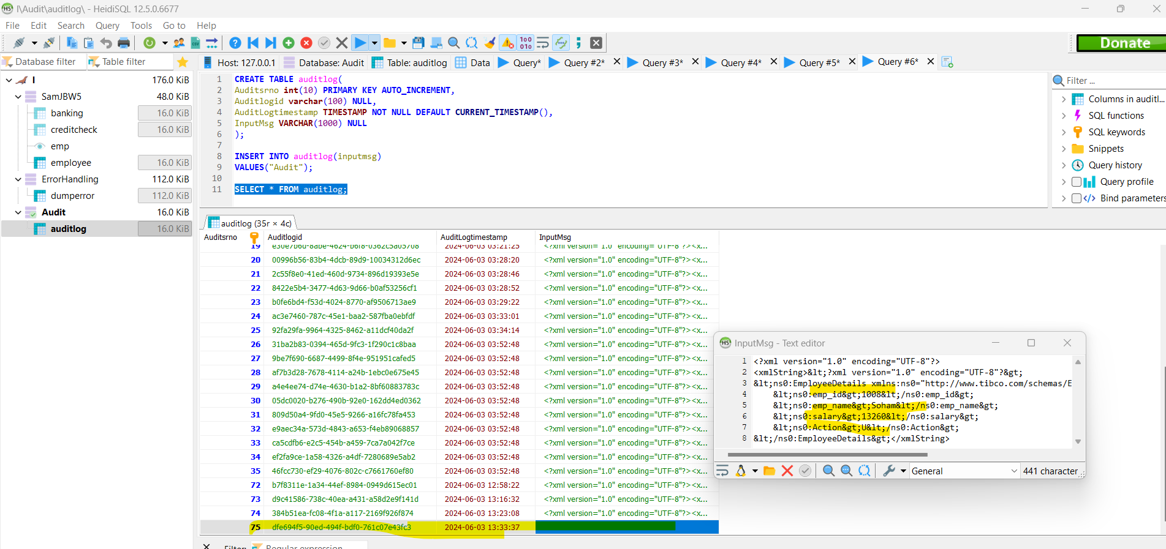

**B)Error scenario: Employee doesn’t exist**

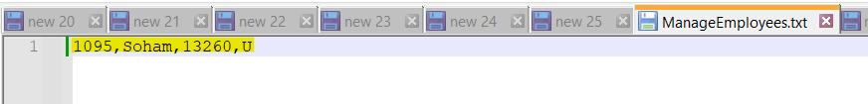

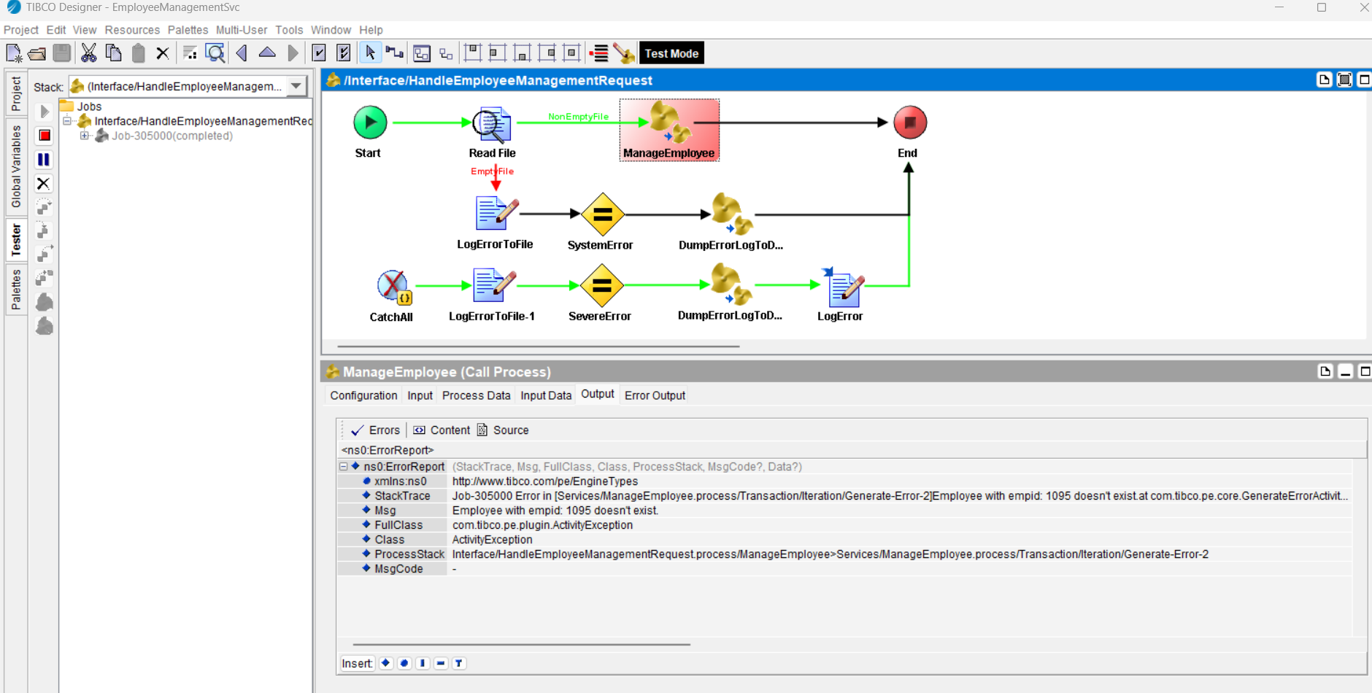

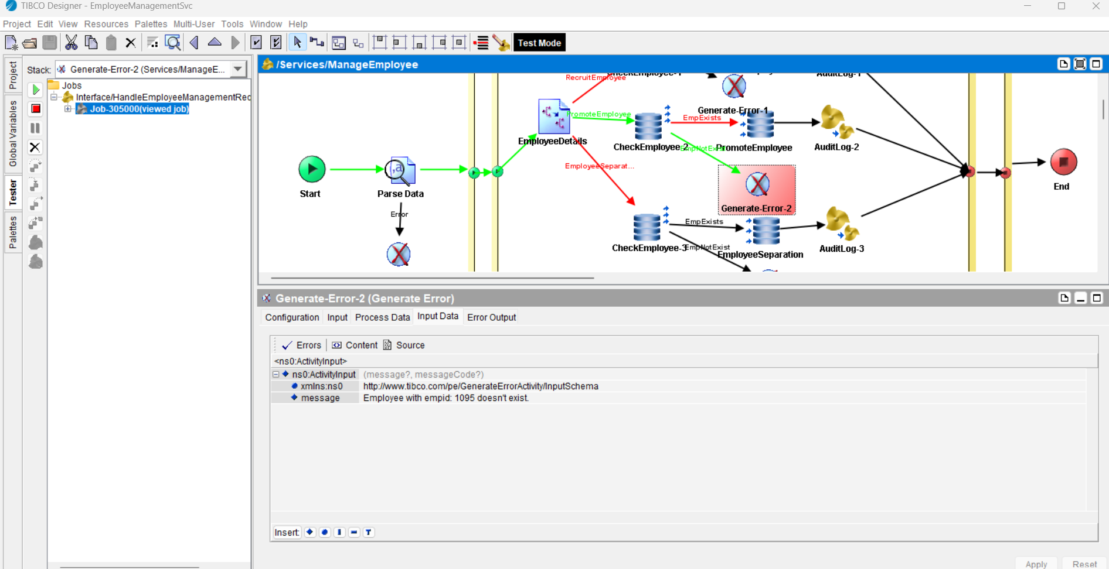

Error details are logged into the database:

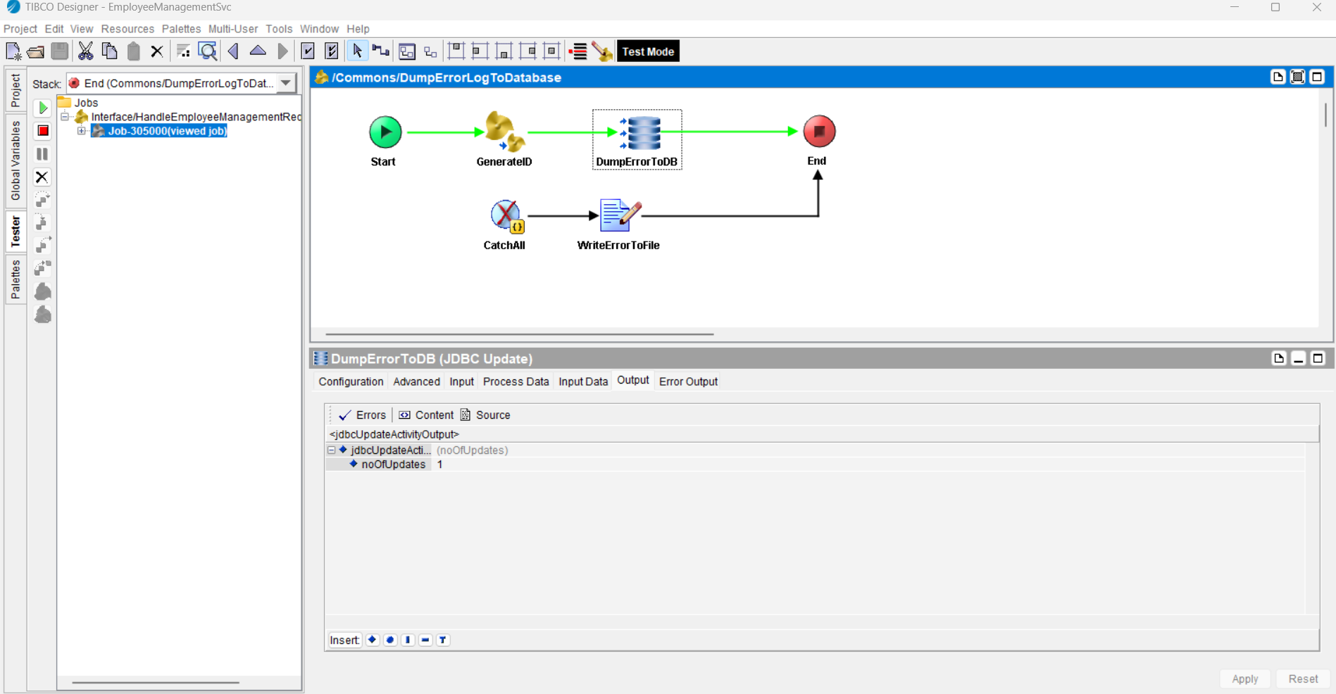

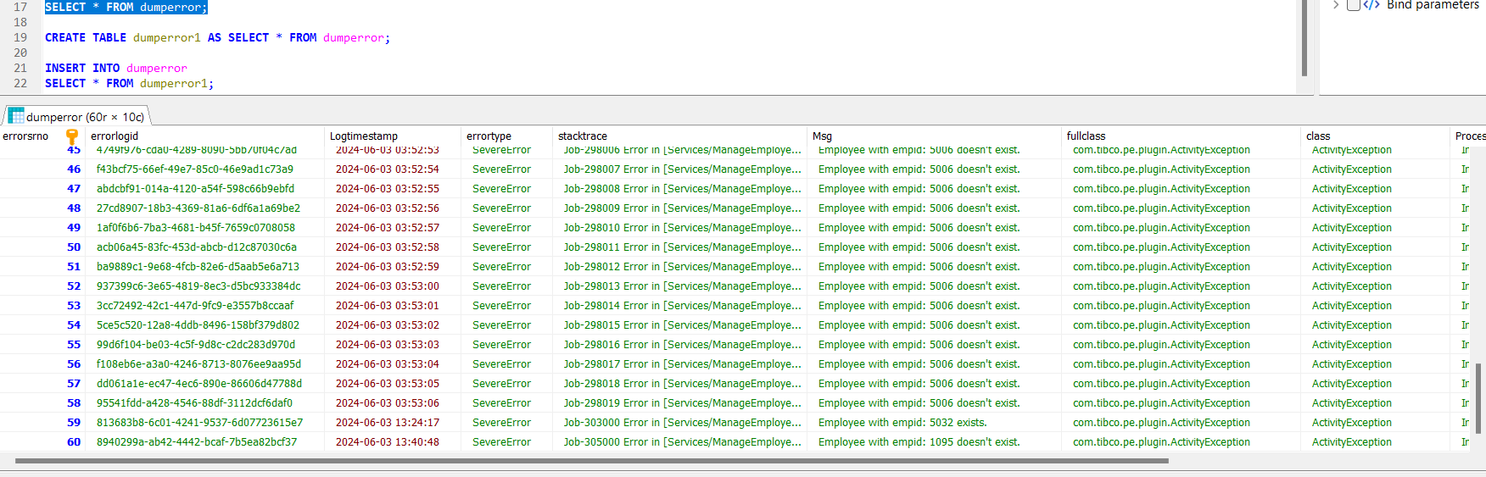

**Scenario 3:** Employee separation

**A)Success scenario: Employee exists**

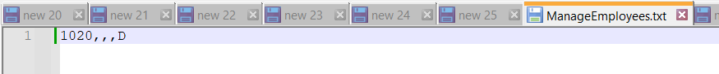

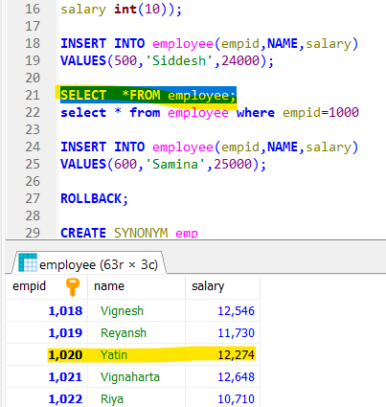

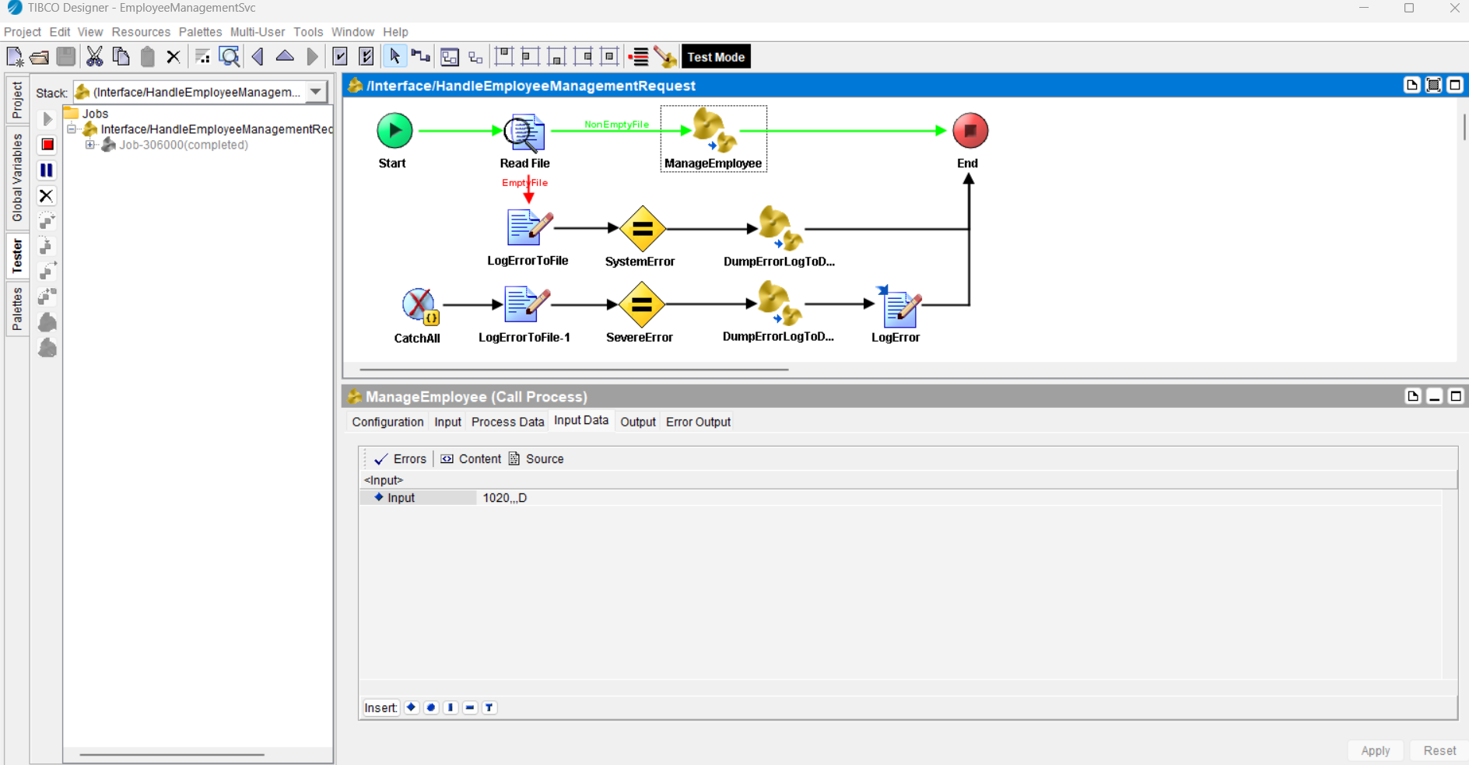

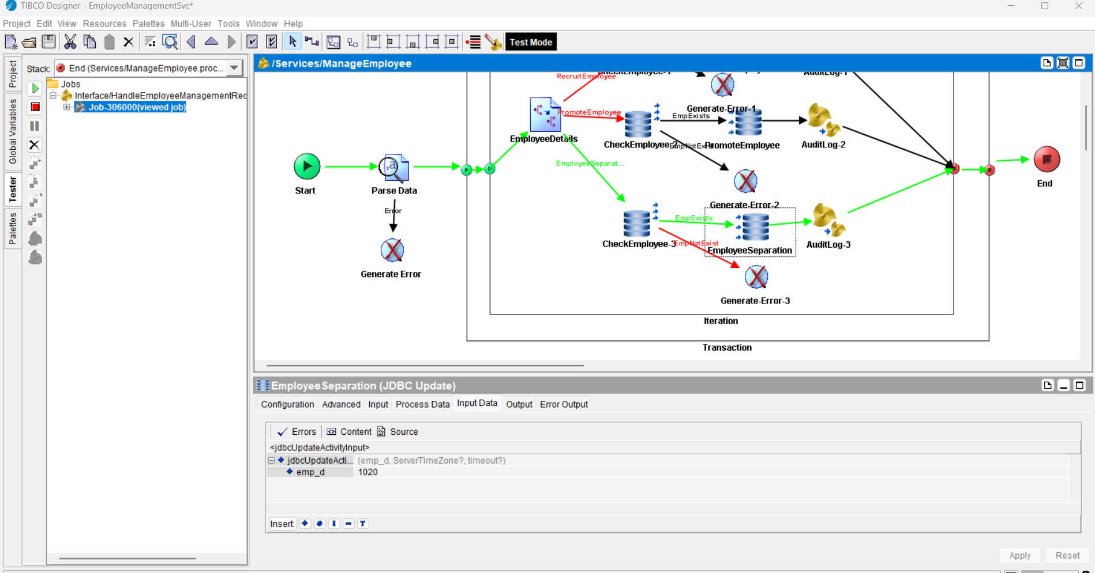

**Employee details are deleted from the database successfully.**

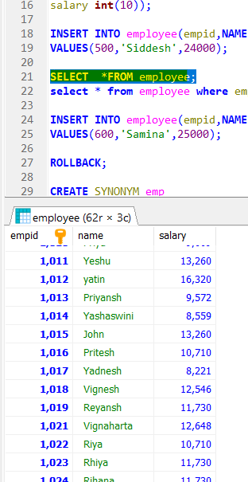

**Input details are logged into the database for audit purpose.**

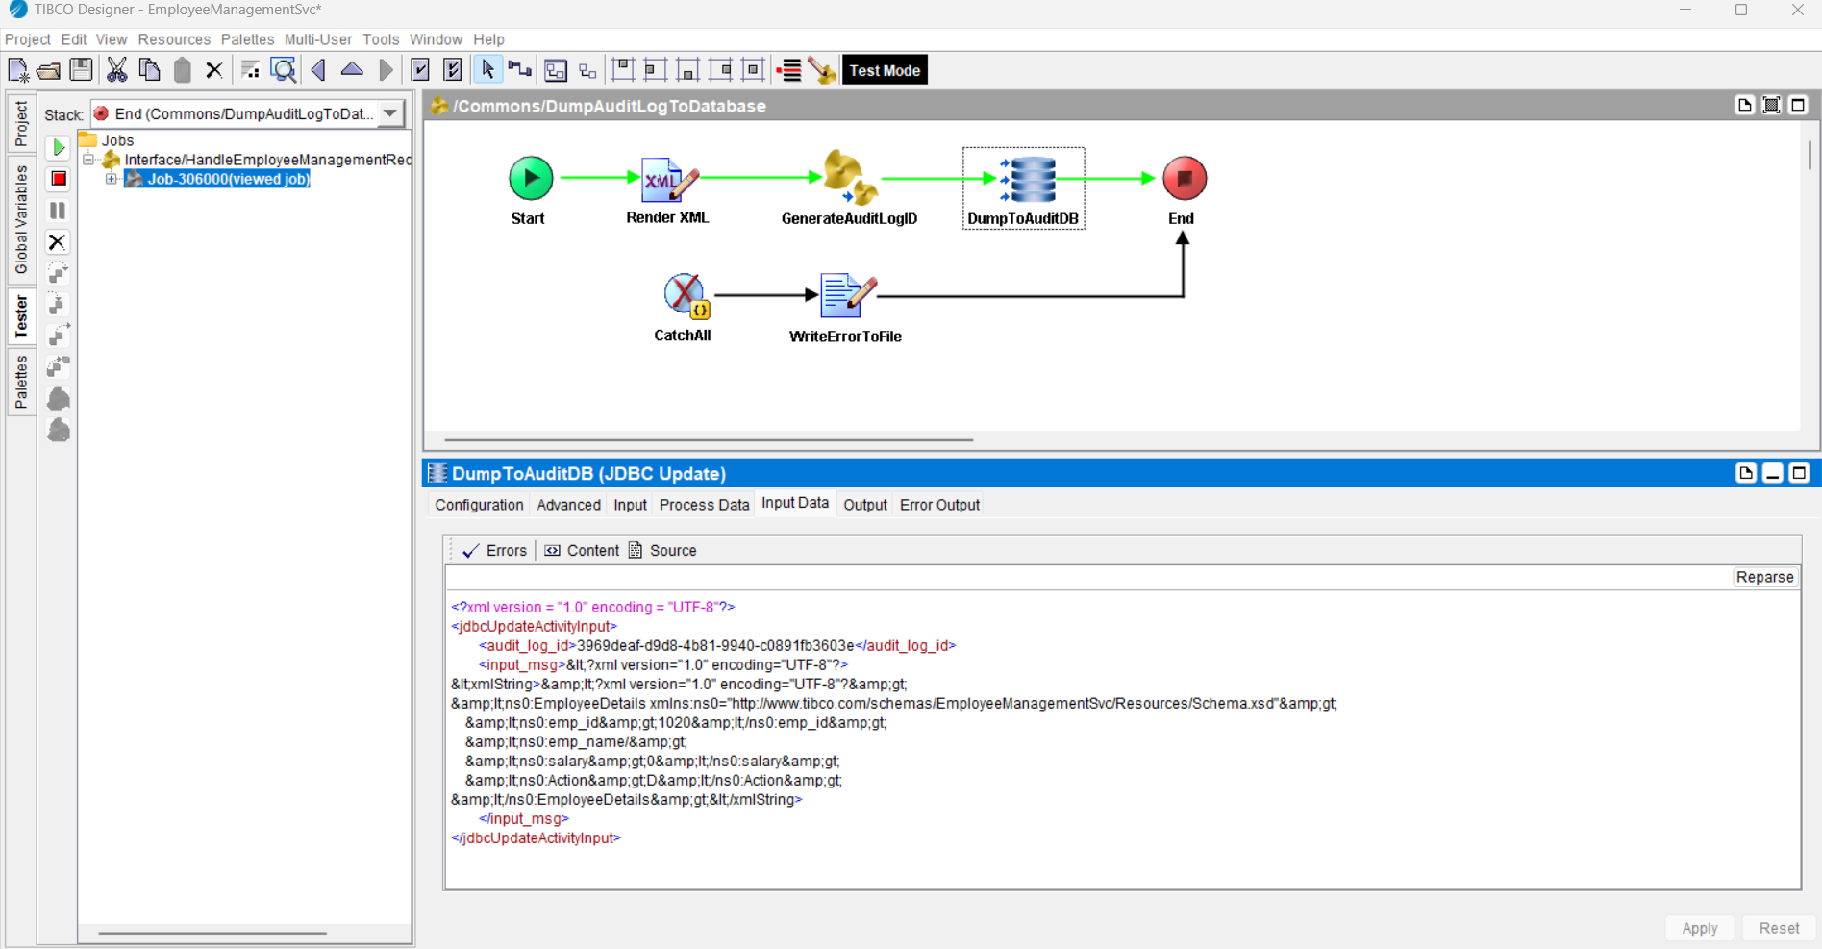

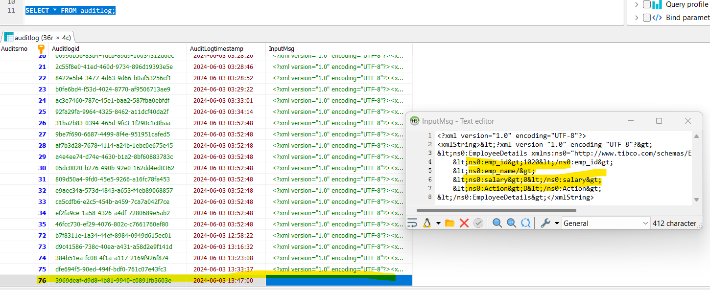

**B)Error scenario: Employee doesn’t exist**

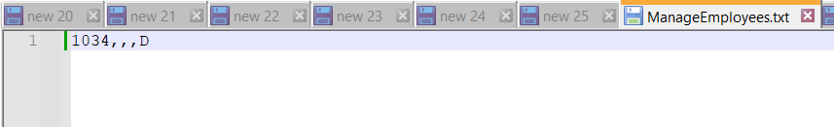

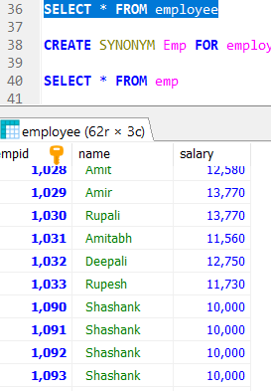

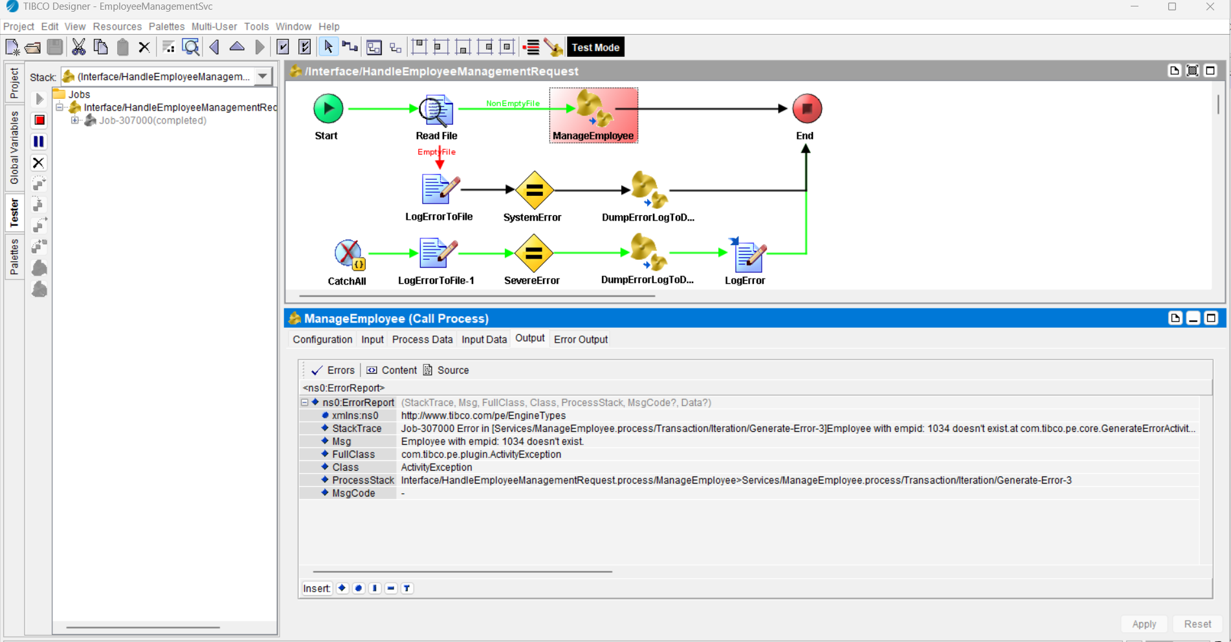

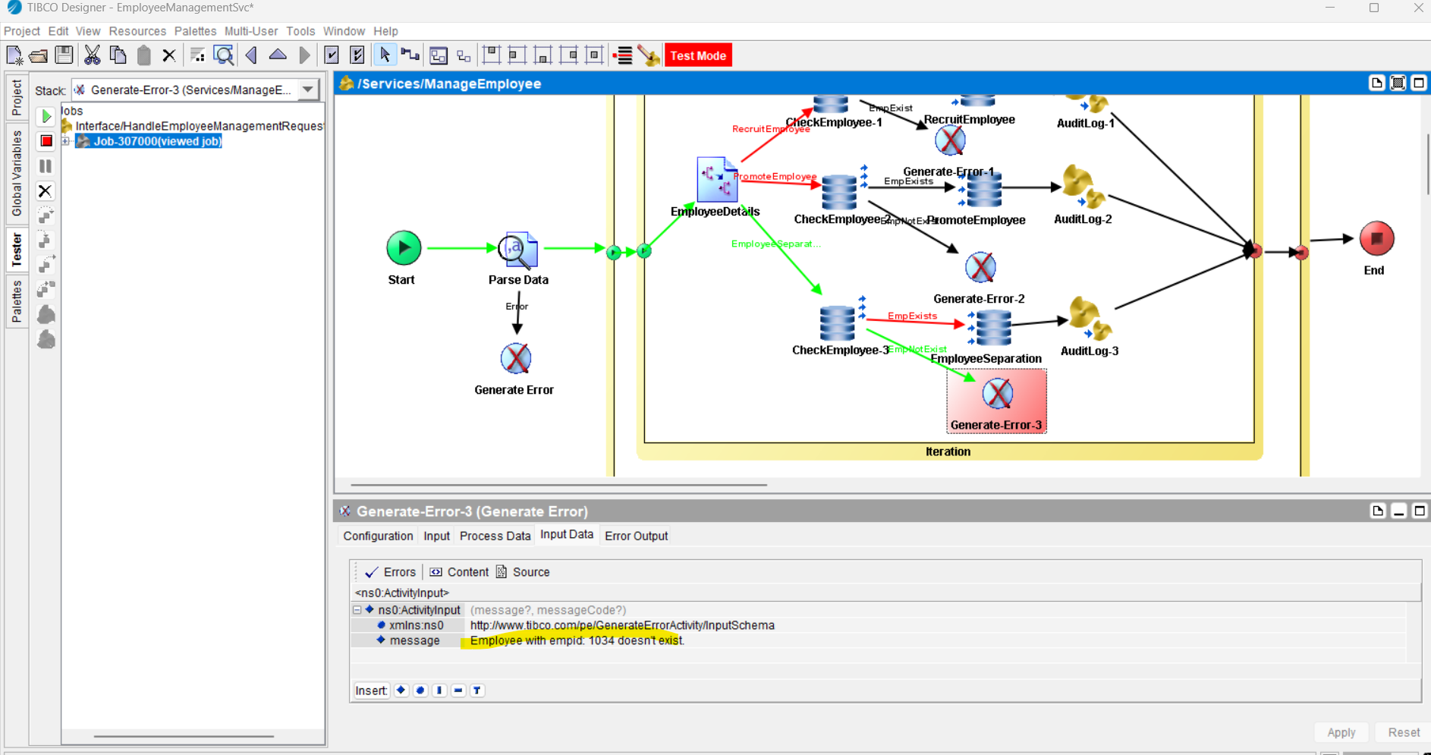

Error details are logged into the database:

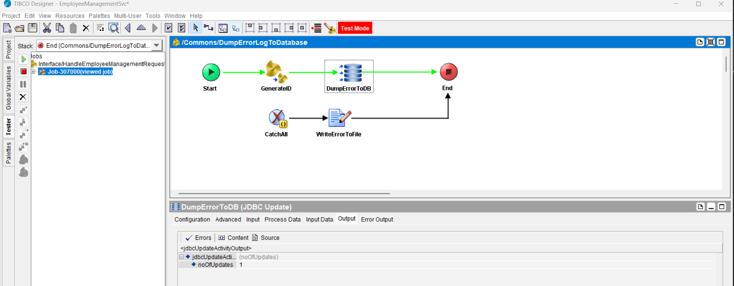

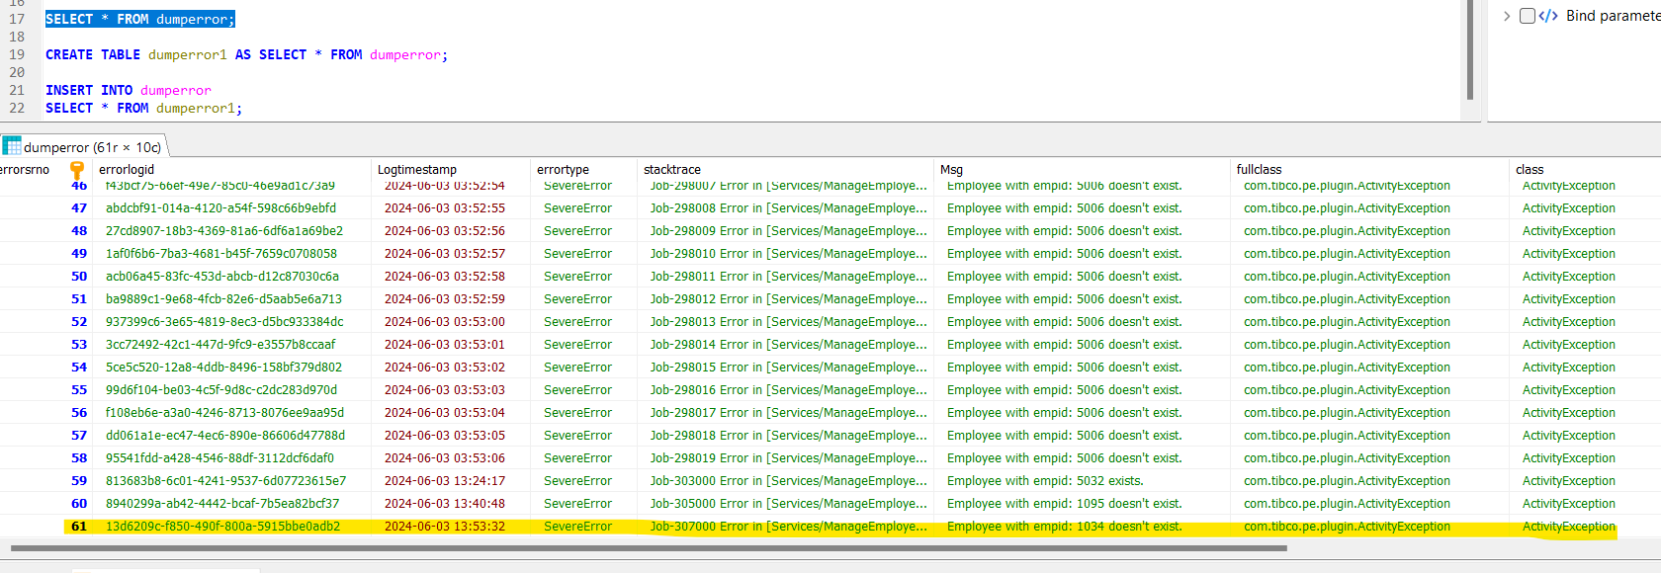

**Deployment to Tibco Administrator:**

**Created an .ear file.**

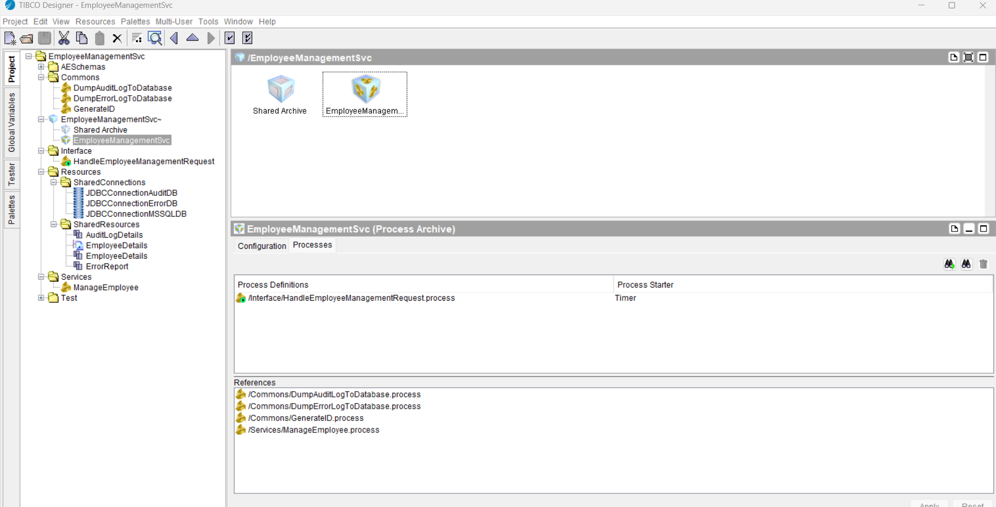

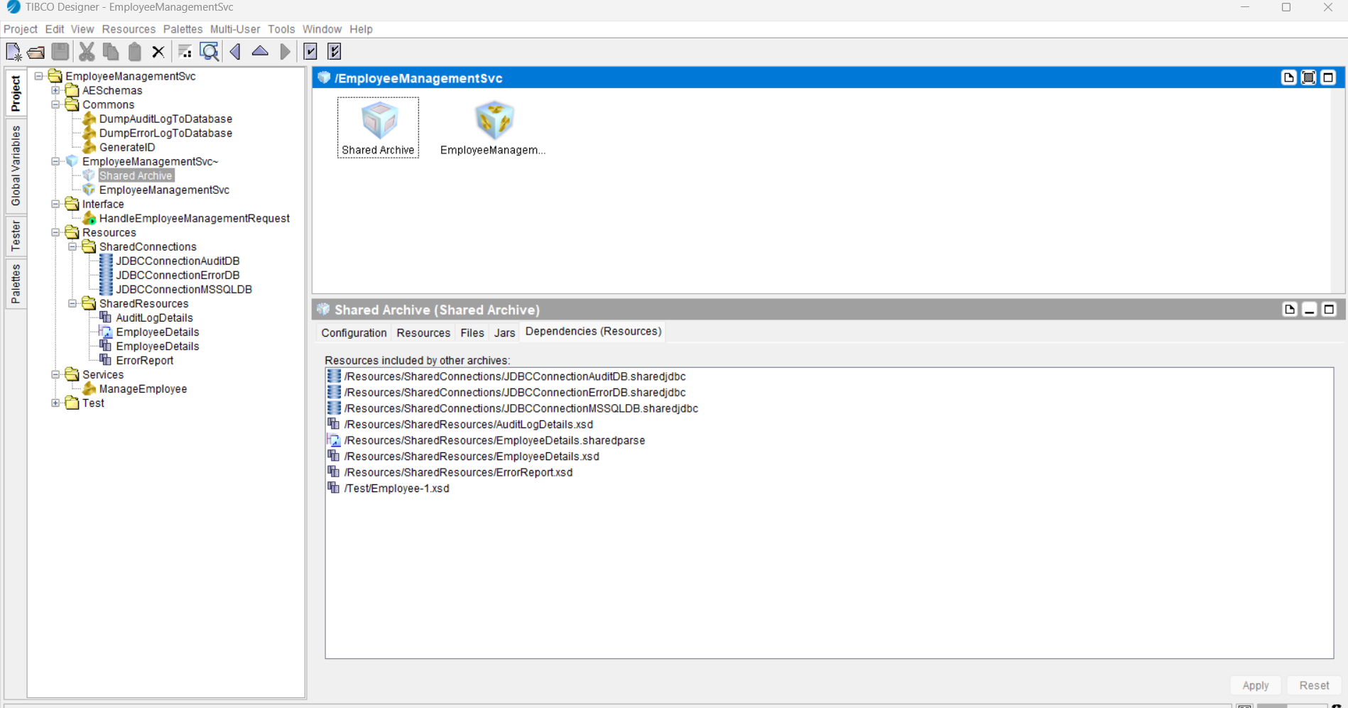

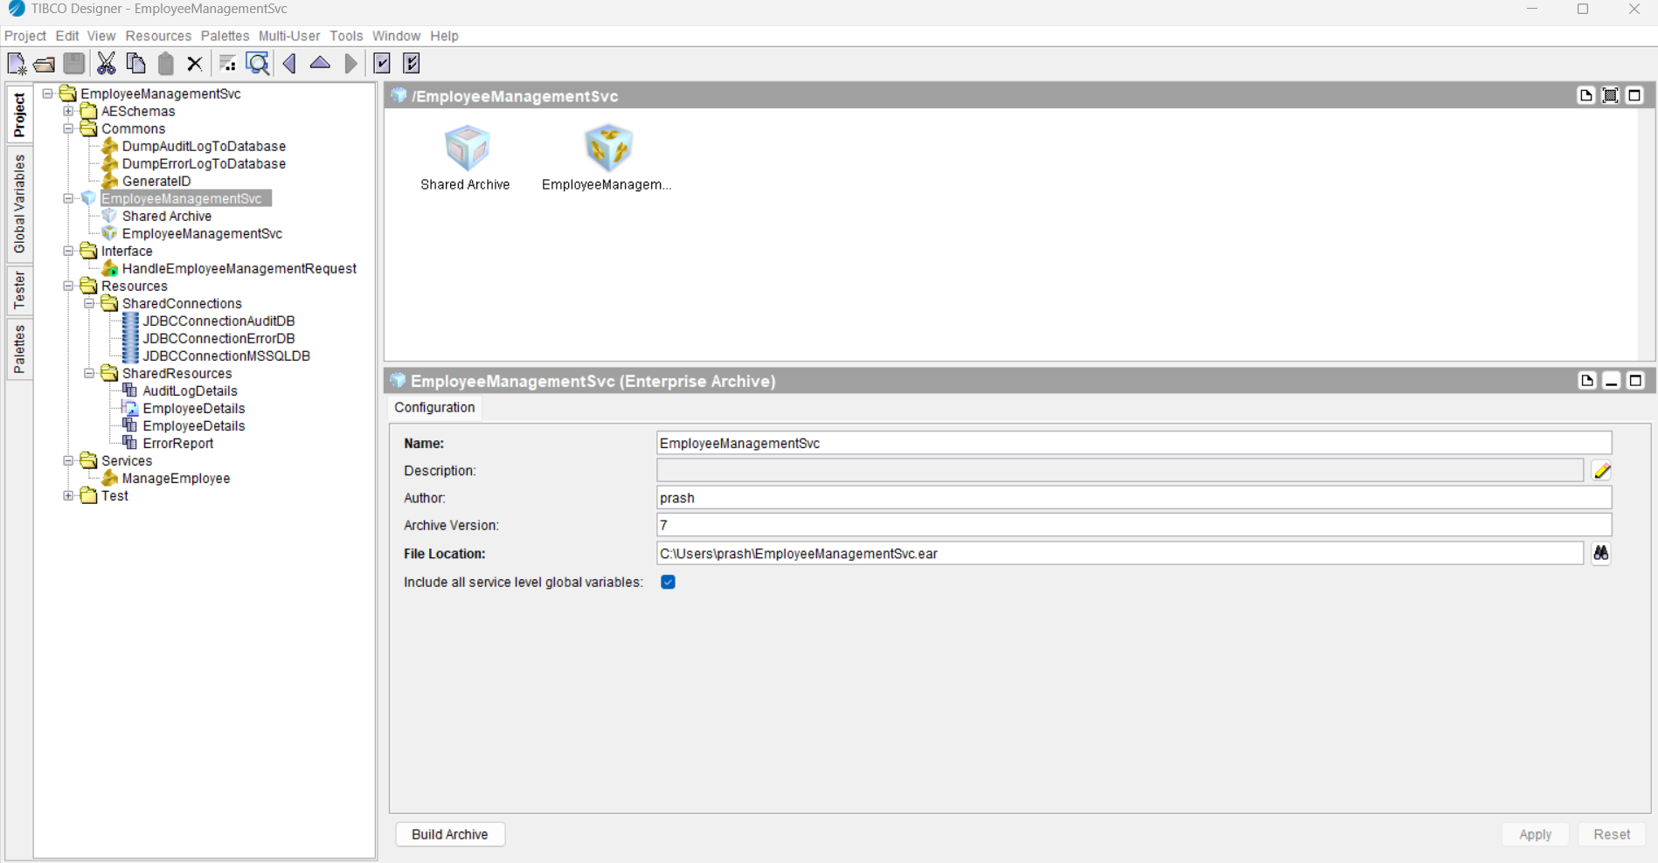

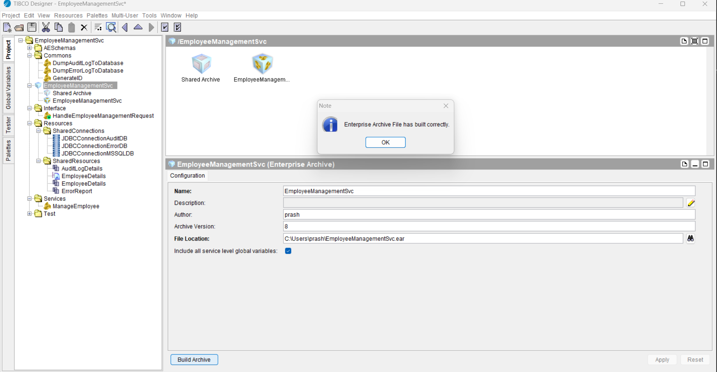

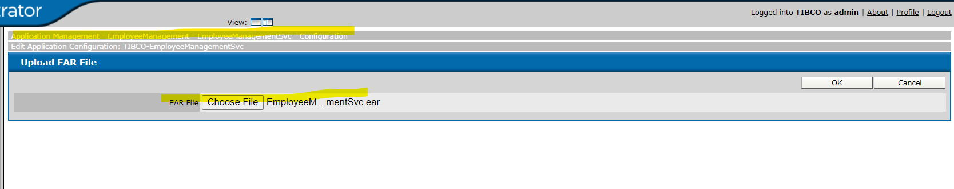

Application has been successfully deployed on TIBCO Administrator.

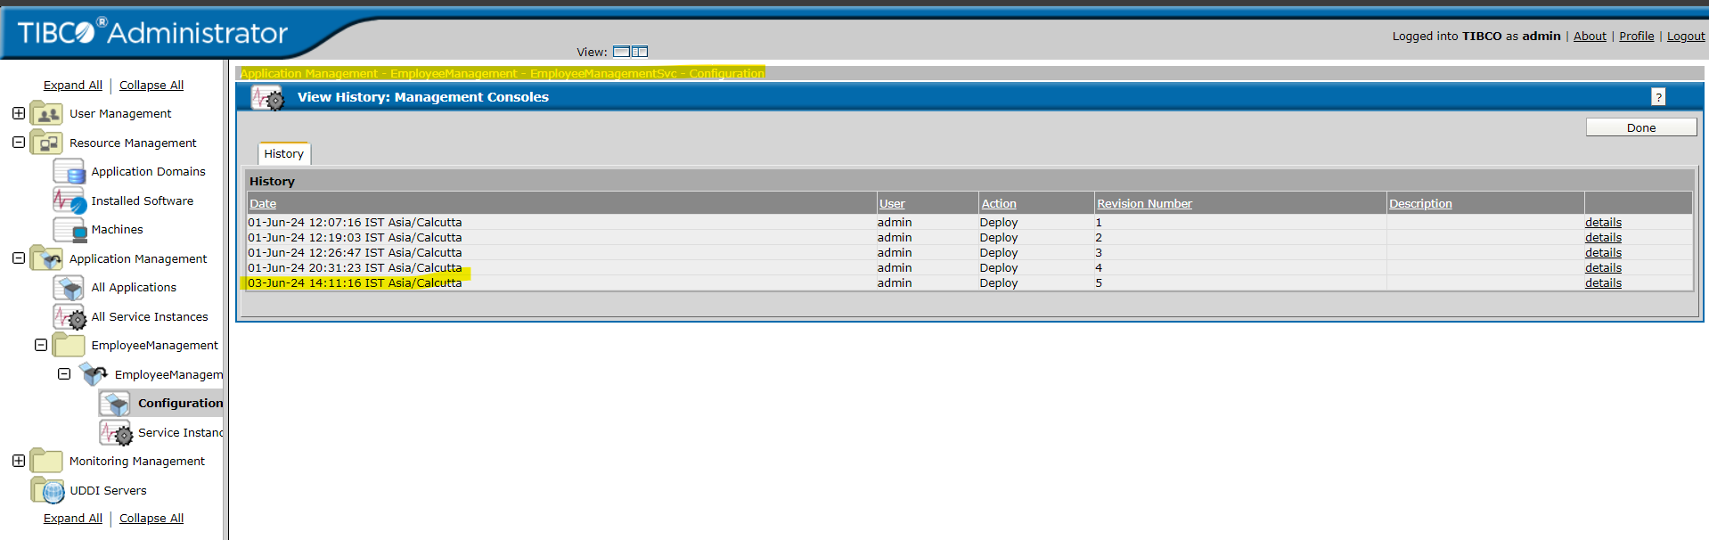

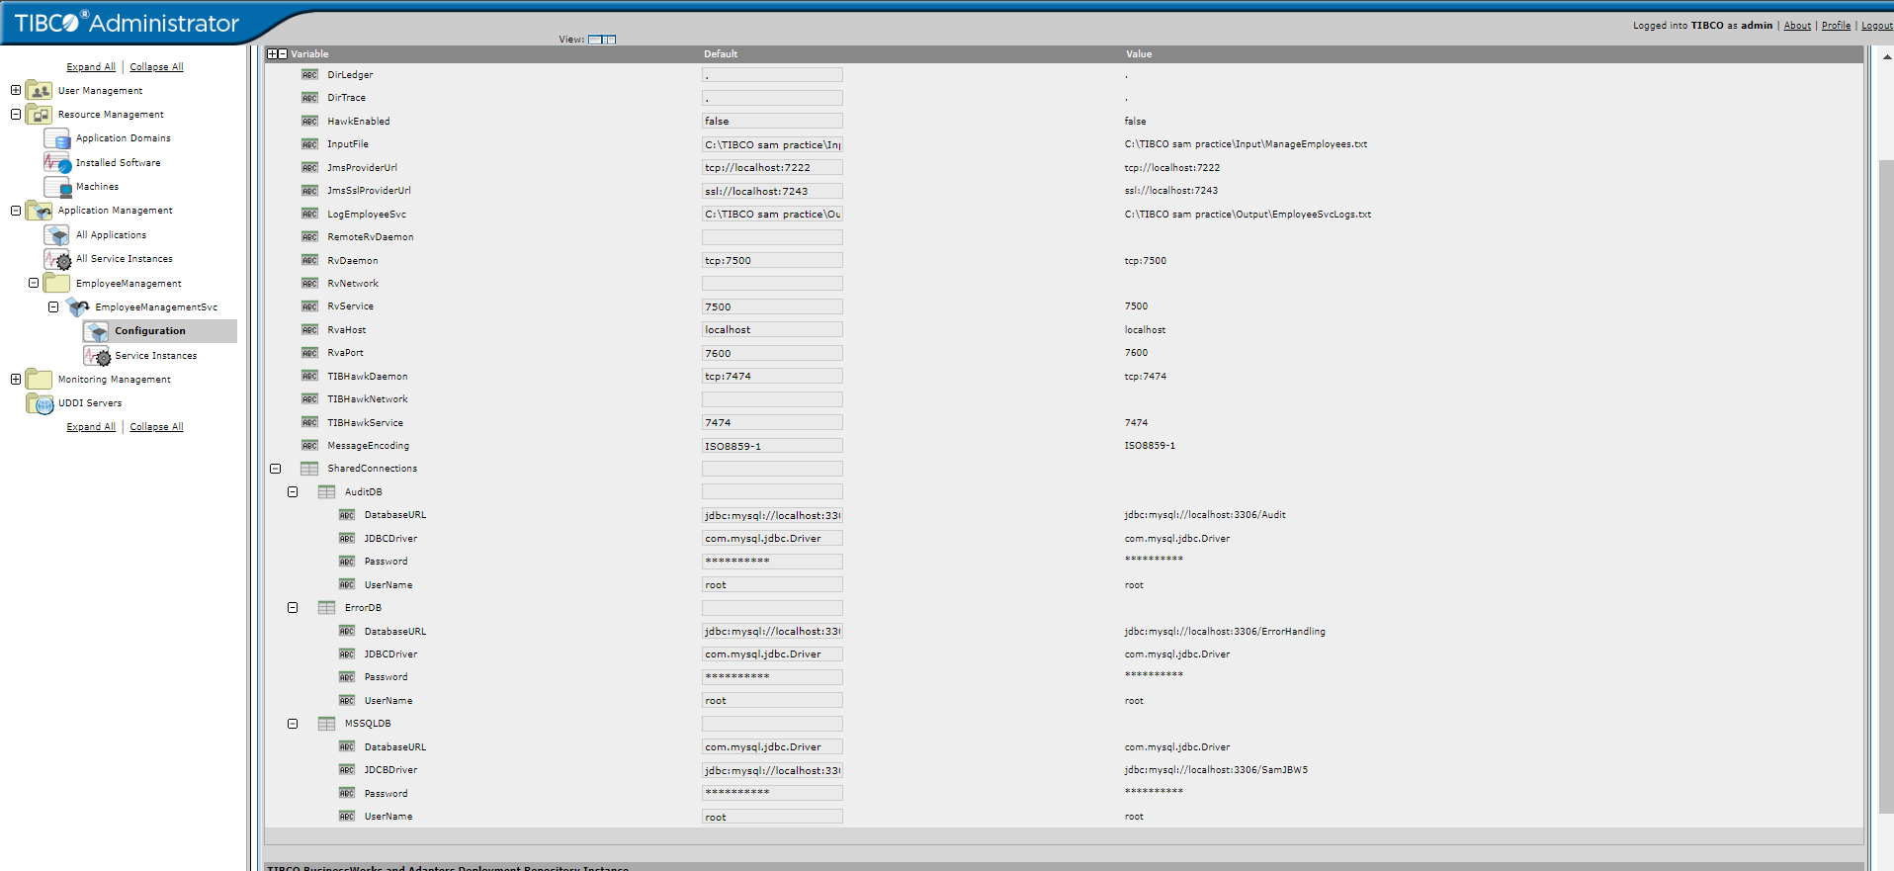

Check process stats:

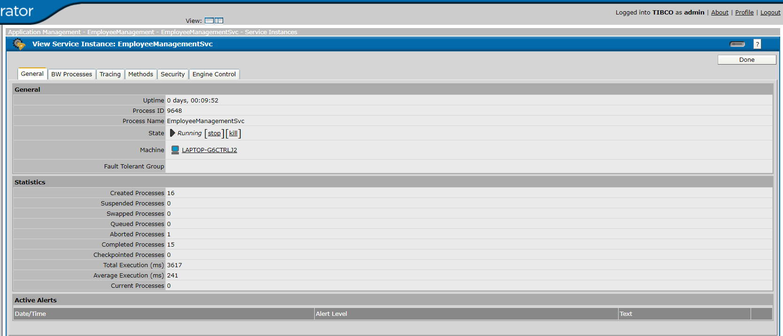

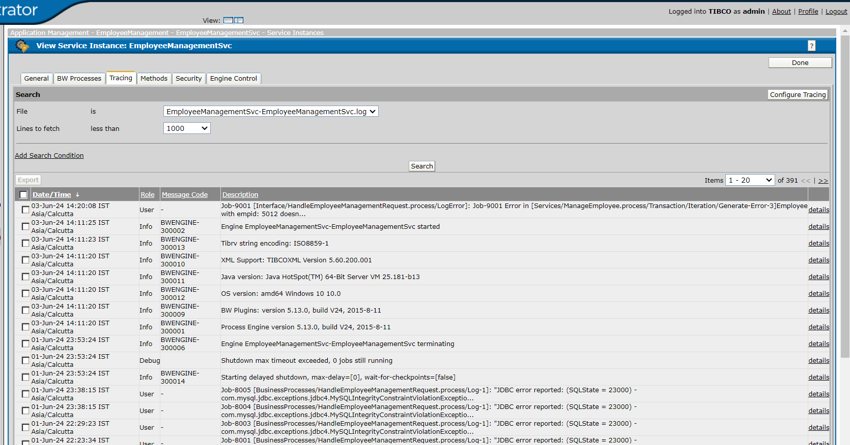

Check process stats for monitoring of the application, ensuring smooth and efficient operations.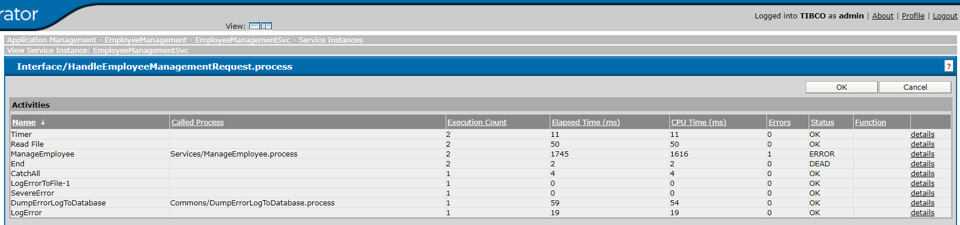

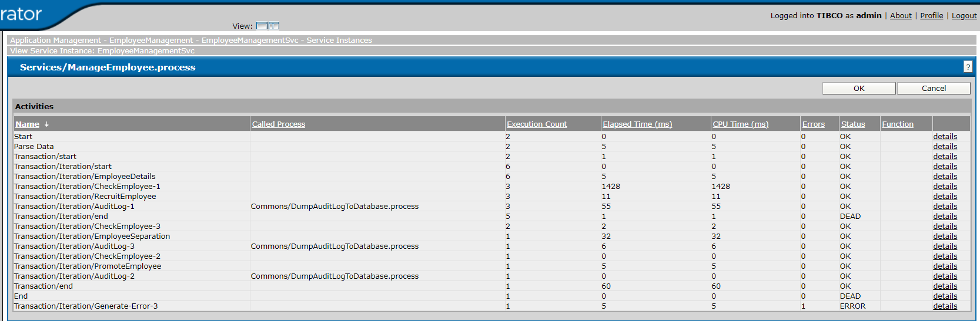

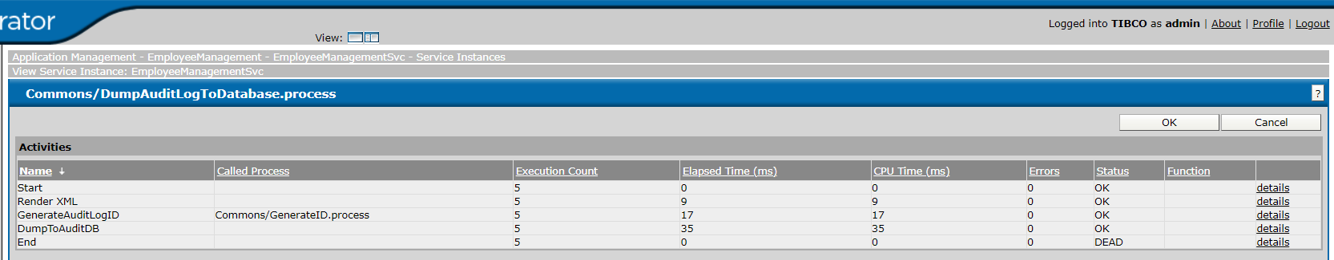

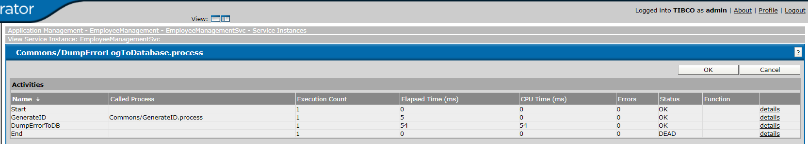

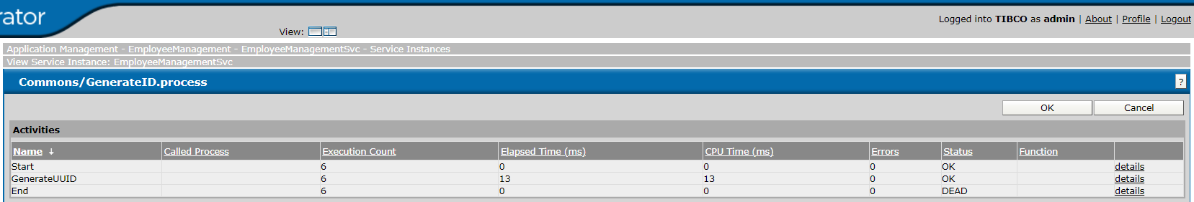

**Thank you…**